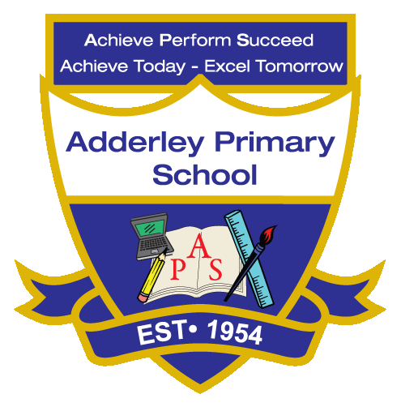
EYFS –Yearly Curriculum Plan (Parent Guide)

EYFS
 | AUTUMN |  | SPRING |  | SUMMER
 | HALF TERM 1 | HALF TERM 2 | HALF TERM 1 | HALF TERM 2 | HALF TERM 1 | HALF TERM 2
TOPIC/FOCUS | Move It!  &  Me and My Community | Once Upon a Time/ Traditional Tales | Starry Night | Ready Steady Grow | Animal Safari | Moving On!
KEY KNOWLEDGE & SKILLS | Communication & Language  Understand simple questions, express points of view, and learn nursery rhymes.  Physical Development  Understand moving with control and uses dominant hand to mark make.  PSED  Understand playing with peers and establishing routines.  Literacy  Encouraged to give meaning to their marks and begin recognising letter formation as part of early writing development.  Maths  Develop an understanding of matching and sorting objects and explore one-to-one correspondence.  UW  Develop a sense of responsibility and an understanding of their role within the community.  EAD  Foster imagination through role play and exploration of materials. | Communication & Language  Continue learning nursery rhymes and use role play to explore different perspectives and situations of characters.  Physical Development  Develop core strength through large-body movements and refine hand control with cutting activities.  PSED  Foster empathy for others and strengthen personal resilience through understand roles of characters.  Literacy  Progress from mark-making to letter formation, emphasising correct letter orientation.  Maths  Explore and understand numbers from 1–5.  UW  Children will develop respect for different religions and cultures and understand seasonal changes in the natural world.  EAD  understand the process of making Porridge and continue to develop their imagination through related activities. | Communication & Language  Begin to develop language and vocabulary when expressing views and opinions.  Physical Development  Understand self-care, build strength through large movements, and develop better control when holding a pencil using a tripod grip.  PSED  Develop an understanding of rules, identity, and explore different feelings and emotions.  Literacy  Develop writing skills, progressing to independently write CVC words, captions, and simple sentences.  Maths  Develop an understanding of 2D and 3D shapes, mass, and capacity, with progression to numbers 6, 7, and 8.  UW  Explore celebrations such as New Year, Chinese New Year, and Ramadan, make themed foods, and learn about seasonal changes.  EAD  Design and make their own products, exploring ideas, planning their creations, selecting materials, and refining their work. | Communication & Language  Develop confidence in using language and vocabulary when expressing views and opinions.  Physical Development  Develop self-care skills, improve strength through large, coordinated movements, and enhance fine motor control by using a tripod grip when holding a pencil.  PSED  Developing knowledge on healthy eating and understanding the importance of making choices to keep healthy.  Literacy  Developing more accuracy in formation and writing more detailed sentences focusing on grammar.  Maths  Develop a secure understanding of numbers within 10, alongside strengthening knowledge and skills in measurement.  UW  Develop an understanding of the changes that occur during the spring season, while also learning about a variety of festivals celebrated during this time.  EAD  Engage in free-style fruit painting, observational drawing of fruits, and the preparation of fruit kebabs. | Communication & Language  Demonstrate confidence in expressing agreement and disagreement appropriately during conversations.  Physical Development  Apply strength and control across a range of activities, while demonstrating a good understanding of health care.  PSED  Develop an understanding of respect, explore and value individuality, and strengthen knowledge of internet safety.  Literacy  Retell stories while applying correct use of capital letters, finger spaces, and full stops, alongside developing accurate letter formation.  Maths  Explore teen numbers and develop understanding of sharing and grouping, alongside learning about 3D shapes.  UW  Develop knowledge of safari and farm animals, including an understanding of carnivores and herbivores, while also exploring seasonal changes.  EAD  Engage in painting and junk modelling using recycled materials, while developing singing skills with a focus on pitch and rhythm. | Communication & Language  Engage in extended conversations with confidence, using varied and engaging language, while demonstrating assurance in taking turns during discussions.  Physical Development  Demonstrate core strength and apply it effectively across both gross and fine motor skills.  PSED  Respect the feelings of others while understanding one’s own emotions, demonstrate the ability to self-regulate, and develop an understanding of social situations.  Literacy  Compose sentences across a range of contexts, using capital letters, finger spaces, and full stops, while ensuring accurate letter formation in the correct direction.  Maths  Develop skills in composing and decomposing shapes, understanding patterns, describing positions, and consolidating counting to 20, including sequences of 2, 5, and 10.  UW  Develop an understanding of the summer season and prepare for the transition to Year 1.  EAD  Mix paints to create colours and apply imagination in producing creative artworks.
ORACY OUTCOME | Role Play | Role Play | Taking Turns – offering opinions. | Taking Turns – expressing views. | Role Play | Role Play

