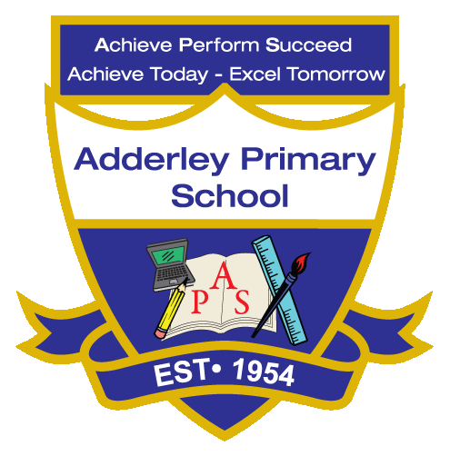
WRITNG – Yearly Curriculum Plan (Parent Guide)

YEAR 6
 | AUTUMN |  | SPRING |  | SUMMER
 | HALF TERM 1 | HALF TERM 2 | HALF TERM 1 | HALF TERM 2 | HALF TERM 1 | HALF TERM 2
TOPIC/FOCUS | Blood Heart & Circulatory System  Balanced Argument | Frozen Kingdom  Non-chronological Report | A Child’s War & Britain at War  Historical Narrative | Islamic Golden Age & Islamic Art  Short Patterned Poetry | Islamic Golden Age & Islamic Art  Biography | Trailblazers, Barrier Breakers  Adventure Narrative
KEY KNOWLEDGE & SKILLS | Write balanced arguments discussing organ donation using formal language and clear viewpoints. Focus on causal conjunctions, fronted adverbials, parenthesis and accurate punctuation to organise ideas. | Write non-chronological reports about the Titanic using headings, subheadings and technical vocabulary. Focus on formal tone, complex sentences and accurate punctuation to present information clearly. | Write historical narratives based on events during the Blitz, developing atmosphere, dialogue and clear story structure. Focus on varied sentence structures, figurative language and accurate speech punctuation. | Explore short, patterned poems inspired by On the Move. Pupils will write poems using structures such as acrostic, shape and cinquain. Focus on precise vocabulary, rhythm and punctuation for effect. | Research and write biographies about Islamic artists such as Kamāl ud-Dīn Behzād. Focus on chronological organisation, formal language, expanded noun phrases and accurate punctuation within longer sentences. | Write adventure narratives inspired by stories of the Underground Railroad, developing tension, character and action. Focus on descriptive vocabulary, varied sentence lengths, dialogue and accurate punctuation.
ORACY OUTCOME | Children debate and justify viewpoints about organ donation. | Children present factual reports about the Titanic. | Children perform and present historical narratives. | Children perform their poems aloud using expression and clear articulation. | Children present biographies about influential historical figures. | Children perform adventure narratives to entertain an audience.

