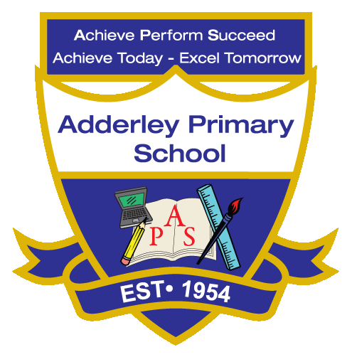
English Reading –Yearly Curriculum Plan (Parent Guide)
YEAR 6
 | AUTUMN |  | SPRING |  | SUMMER
 | HALF TERM 1 | HALF TERM 2 | HALF TERM 1 | HALF TERM 2 | HALF TERM 1 | HALF TERM 2
TOPIC/FOCUS | Blood Heart & Circulatory System  Week Junior – Giving the Gift of Life with Doctors’ Help | Frozen Kingdom  Titanic – Margi McAllister  SLS books | A Child’s War & Britain at War  The Boy in the Striped Pyjamas – John Boyne | Islamic Golden Age & Islamic Art  Texts about Islamic artists including Kamāl ud-Dīn Behzād | Islamic Golden Age & Islamic Art  Texts about Islamic artists including Yahya ibn Mahmud al-Wasiti | Trailblazers, Barrier Breakers  Henry’s Freedom Box – Ellen Levine & Kadir Nelson
KEY KNOWLEDGE & SKILLS | Throughout Year 6, pupils develop advanced reading skills through a range of fiction, non-fiction and historical texts linked to their topics. In Autumn 1, pupils read information texts about the circulatory system and organ donation, focusing on retrieving information and discussing viewpoints. In Autumn 2, reading texts about the Titanic supports pupils in identifying key facts and understanding how non-fiction texts are organised. In Spring 1, pupils read The Boy in the Striped Pyjamas, developing inference by exploring how characters respond to events during wartime. In Spring 2, pupils read biographies about artists from the Islamic Golden Age, learning how texts present historical achievements and chronological information. In Summer 1, pupils read Henry’s Freedom Box and related texts about the Underground Railroad, analysing themes of courage and freedom. In Summer 2, pupils read texts about Civil Rights leaders, strengthening their ability to summarise information, interpret viewpoints and discuss the impact of historical events.

