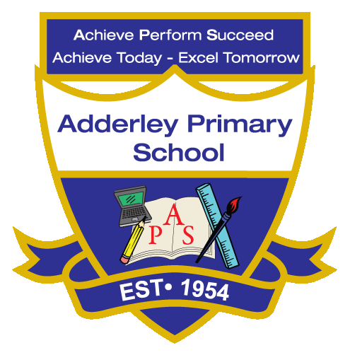
Geography –Yearly Curriculum Plan (Parent Guide)

YEAR 6
 | AUTUMN |  | SPRING |  | SUMMER
 | HALF TERM 1 | HALF TERM 2 | HALF TERM 1 | HALF TERM 2 | HALF TERM 1 | HALF TERM 2
TOPIC/FOCUS | Blood Heart | Frozen Kingdom | A Child’s War  &  Britain at War | Islamic Golden Age  Islamic Art | Islamic Golden Age  Islamic Art | Trailblazers, Barrier Breakers
KEY KNOWLEDGE & SKILLS | Explore how geography influenced the spread of medical knowledge, including the movement of ideas and texts between regions like the Middle East, Europe, and North Africa. Learn how trade routes, cities, and cultural centres shaped the exchange of discoveries and treatments from the Islamic Golden Age to Europe. | Measure temperature, humidity, and snow quality, and record observations of the environment and visitor experience.  Analyse the data, compare it to natural snow conditions, and reflect on how the Snowdome differs from a real ski environment.  Draw conclusions about the effects of indoor vs. outdoor snow climates. | Locate cities and ports bombed during the Blitz using maps, grid references, and Google Earth. Examine why certain areas were targeted and identify geographical features that influenced vulnerability. Understand how geography shaped wartime events and strategies. | Examine Baghdad’s location and its importance as a centre of learning and trade.  Map the Silk Road and other trade routes, exploring how geography enabled cultural exchange, commerce, and the spread of Islamic influence. | Map the Silk Road and Baghdad’s trade routes to see how geography enabled trade, the spread of Islamic teachings, and cultural exchange. Explore how Baghdad’s location supported its role as a centre of learning, innovation, and the introduction of new technologies like paper. | Identify cultural hubs for Black art such as Harlem, Brixton, Lagos, and Kingston, and plot them on a map. Explore how migration, community, and location influenced the development of these centres and the spread of Black artistic expression worldwide.
ORACY OUTCOME | Research and Present findings | Listen and respond and ask questions | Group work and discussion | Research and Present findings | Group work and discussion | Answer questions in the role of a significant artist.

