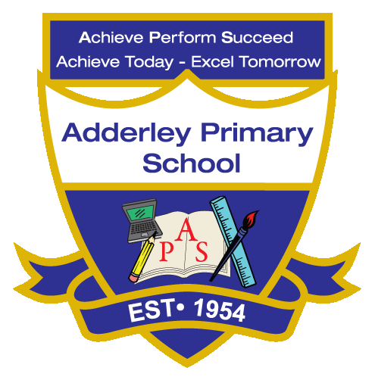
English Reading –Yearly Curriculum Plan (Parent Guide)
YEAR 5
 | AUTUMN |  | SPRING |  | SUMMER
 | HALF TERM 1 | HALF TERM 2 | HALF TERM 1 | HALF TERM 2 | HALF TERM 1 | HALF TERM 2
TOPIC/FOCUS | Stargazers & Earth and Space  Hidden Figures – Margot Lee Shetterly | Fallen Fields (WW1 & WW2)  Safiyyah’s War – Hiba Noor Khan | Sow, Grow and Farm & Allotment  Newspaper articles and texts about farming and food production | Firedamp & Davy Lamps  The Chimney Sweeper – William Blake  In the Black Country (adapted poem) | Davy Lamps  The Chimney Sweeper – William Blake  In the Black Country (adapted poem) | Pharaohs  Ancient Egyptian texts and artefact information  SLS books
KEY KNOWLEDGE & SKILLS | Throughout Year 5, pupils develop their reading skills through a range of fiction, non-fiction and poetry linked to their class topics. In Autumn 1, pupils read Hidden Figures and related texts about space exploration, focusing on retrieving information, understanding character motivation and discussing themes such as determination and equality. In Autumn 2, reading Safiyyah’s War supports pupils in exploring historical context and developing inference by examining how events affect characters. In Spring 1, pupils read newspaper articles and information texts about farming and food production, identifying key facts and recognising how authors present different viewpoints. In Spring 2, pupils explore poetry and historical texts about mining and industrial life, analysing imagery, vocabulary and themes. In Summer 1, pupils read a range of Ancient Egyptian texts, developing their ability to retrieve information and understand technical vocabulary. In Summer 2, pupils deepen these skills by summarising key ideas and discussing how non-fiction texts present historical information clearly.

