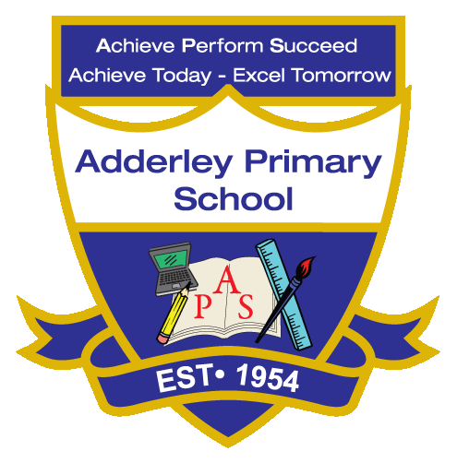
Music –Yearly Curriculum Plan (Parent Guide)

YEAR 5
 | AUTUMN |  | SPRING |  | SUMMER
 | HALF TERM 1 | HALF TERM 2 | HALF TERM 1 | HALF TERM 2 | HALF TERM 1 | HALF TERM 2
TOPIC/FOCUS | Stargazers & Earth and Space  Composition Notation | Fallen Fields (WW1 & 2)  Blues | Sow, Grow and Farm & Allotment  South and West Africa | Firedamp & Davy Lamps  Composition to Represent the Festival of Colour | Firedamp & Davy Lamps  Looping and Remixing | Pharaohs  Musical Theatre
KEY KNOWLEDGE & SKILLS | Develop skills in creating and recording compositions using symbols and simple notation. Understand that musical notation represents pitch, rhythm, and dynamics, and can communicate ideas to performers. | Develop skills in creating and recording compositions using symbols and simple notation. Understand that musical notation represents pitch, rhythm, and dynamics, and can communicate ideas to performers. | Develop ensemble, rhythm, and improvisation skills using instruments and body percussion. Understand that African music uses layered rhythms, polyrhythms, and community participation to create vibrant musical textures. | Develop composition and creative skills by choosing instruments, pitch, tempo, and dynamics to convey an idea or event. Understand that music can represent concepts, stories, or celebrations through choices in sound and structure. | Develop skills in repeating, layering, and combining musical ideas to create loops and remixes. Understand that loops are repeated patterns and remixing allows musicians to rearrange and innovate with existing material. | Develop singing, performance, and ensemble skills in a theatrical context. Understand that musical theatre combines music, lyrics, and acting to convey narrative, character, and emotion.
ORACY OUTCOME | Presentation | Performance Presentation | Demonstration & Peer Feedback | Storytelling Through Music |  | Group Reflection
  Peer Feedback Discussion

