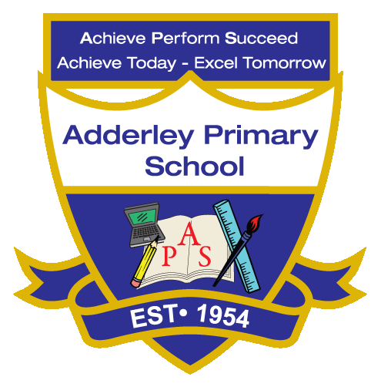
History –Yearly Curriculum Plan (Parent Guide)

YEAR 5
 | AUTUMN |  | SPRING |  | SUMMER
 | HALF TERM 1 | HALF TERM 2 | HALF TERM 1 | HALF TERM 2 | HALF TERM 1 | HALF TERM 2
TOPIC/FOCUS | Stargazers  &  Earth and Space | Fallen Fields (WW1 x2) | Sow, Grow and Farm | Firedamp & Davy Lamps | Firedamp & Davy Lamps | Pharaohs
KEY KNOWLEDGE & SKILLS | Research significant Muslims in space exploration, such as Farouk Al-Baz, who helped plan the Apollo moon missions at NASA. Explore other Muslims who were among the first in space, why their achievements were important, why they are less well known, and how successful their missions were. | Explore the causes and key events of the First World War. Learn about important individuals, weapons, and technology used in the war. Study the Christmas Truce and the impact of the war on food, rationing, and life on the home front and in the trenches. | Explore the history of farming and allotments, and how people have grown crops and kept animals over time. Learn how climate, soil, and location influenced agriculture in places like Jersey and California. Study how allotments supported communities and how farming methods have changed over time. | Learn how coal powered the Industrial Revolution and made the Black Country a key industrial region. Explore how rich coal seams supported mines, factories, and homes. Visit the Black Country Museum to see artefacts and demonstrations that show what coal mining was like in the past. | Learn how coal shaped transport networks like canals, railways, and ports, supporting towns and economic growth. Explore mining conditions, including the work of children, and reflect on life underground. Compare past and present coal mining, noting changes in technology, working conditions, and coal use. | Research famous pharaohs and their achievements, explore artefacts to learn about daily life, and study Egyptian gods and their roles. Investigate beliefs about the afterlife, including burial practices and tombs, and understand their importance in ancient Egyptian society.
ORACY OUTCOME | Present research findings using subject-specific vocabulary | Debate who started the war | Present research findings using subject-specific vocabulary | Question and answer | Group discussion | Ask and answer questions in the role of an Egyptian pharaoh.

