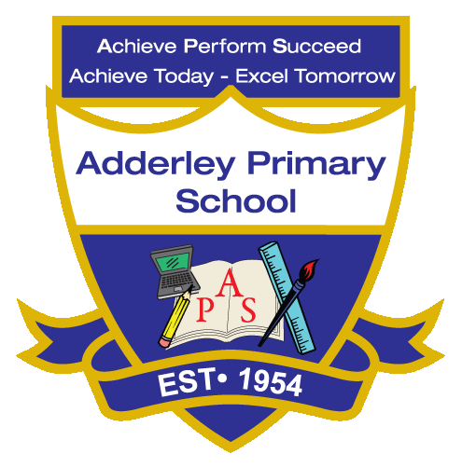
Geography –Yearly Curriculum Plan (Parent Guide)

YEAR 5
 | AUTUMN |  | SPRING |  | SUMMER
 | HALF TERM 1 | HALF TERM 2 | HALF TERM 1 | HALF TERM 2 | HALF TERM 1 | HALF TERM 2
TOPIC/FOCUS | Stargazers  &  Earth and Space | Fallen Fields (WW1 x2) | Sow, Grow and Farm | Firedamp & Davy Lamps | Firedamp & Davy Lamps | Pharaohs
KEY KNOWLEDGE & SKILLS | Explore the Earth’s features using maps, globes, and images, identifying continents, countries, rivers, and volcanoes. Investigate climate, extreme weather, the water cycle, and earthquakes, including their effects and causes. Use fieldwork at the Leicester Space Centre to explore planets and collect data. | Explore the countries involved in the First and Second World Wars using maps, globes, and historical sources. Identify key locations, continents, and cities affected by the wars, and investigate how geography influenced battles, alliances, and strategies. Use maps to understand how events spread across different regions | Explore allotments and how soil, climate, and location affect what can be grown. Visit a local allotment to gather data and make conclusions. Learn how conditions in places like Jersey and California influence farming and crop success. Use maps, Google Earth, and fieldwork to understand how geography shapes agriculture. | Locate the Black Country on a UK map and identify key towns like Dudley, Wolverhampton, Walsall, and Sandwell. Learn that the area got its name during the Industrial Revolution from the thick smoke, soot, and coal dust produced by its mines, factories, and ironworks. | Explore how coal mining affected the environment, including air pollution, waste heaps, water damage, and subsidence. Investigate how old mining sites have been reclaimed or regenerated into parks, tourist sites, or new developments, and consider ways land can be reused in the future. | Locate Egypt on maps, atlases, and globes, identifying surrounding countries, seas, and key cities like Cairo and Giza. Explore its landscape, climate, and major features, including the River Nile and the Valley of the Kings. Create a sketch or digital map marking significant locations with a key.
ORACY OUTCOME | Group discussion | Question and answer session | Data analysis- Share and discuss conclusions | Maps and globes group work | Debate the best way to use former farming land. | Presentation of sketch maps

