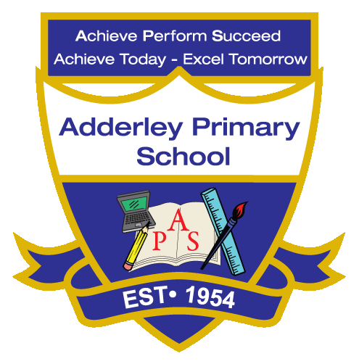
Writing –Yearly Curriculum Plan (Parent Guide)

YEAR 3
 | AUTUMN |  | SPRING |  | SUMMER
 | HALF TERM 1 | HALF TERM 2 | HALF TERM 1 | HALF TERM 2 | HALF TERM 1 | HALF TERM 2
TOPIC/FOCUS | Scrumdiddlyumptious  &  Cook Well, Eat Well  Recount  Setting Description | Through the Ages  &  Prehistoric Pots  Adventure narrative  Non-chronological report | Rocks, Relics  &  Rumbles  Explanation text  Diary | Greenhouse  &  Beautiful Botanicals  Non-chronological report | Gods and Mortals  Information report | One Planet, our World  Persuasive leaflet
KEY KNOWLEDGE & SKILLS | A recount retelling key events focusing on past tense verbs, accurate sentence punctuation and using Year 3 Common Exception Words. A setting description using a range of expanded noun phrases, adjectives and sensory language. | Write an adventure narrative in a clear order consisting of speech dialogue. Focus on correct punctuation, third person and use of descriptive language.  A non-chronological report organising ideas into clear paragraphs. Use co-ordinating and subordinating conjunctions and descriptive vocabulary. | Explore explanation texts using technical vocabulary, factual language, verbs and expanded noun phrases to explain ideas clearly. A diary entry based on a personal experience. Focus on writing in past tense using informal language, rhetorical questions and exclamations. | Write non-chronological reports to present clear information. Organise ideas using sub-headings and paragraphs. Practise using quotes where appropriate, writing in the present tense, and using a range of punctuation. | An information report consisting clear facts including a title, sub-headings and organised paragraphs. Focus on using third person, expanded noun phrases and fronted adverbials to add detail. | Explore persuasive language using rhetorical questions, tier 3 vocabulary and statements to make their writing engaging. Practise different types of sentences, using apostrophes for possession.
ORACY OUTCOME | Digital presentations | Reading aloud with emphasis and clarity | Podcast-style recordings | Audio talk | Storytelling sessions | Peer reflective talk

