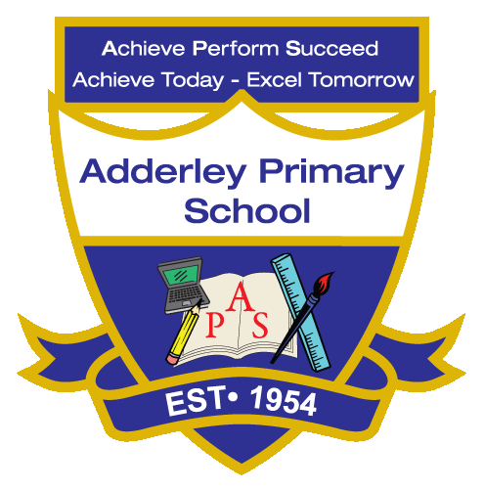
English Reading –Yearly Curriculum Plan (Parent Guide)

YEAR 3
 | AUTUMN |  | SPRING |  | SUMMER
 | HALF TERM 1 | HALF TERM 2 | HALF TERM 1 | HALF TERM 2 | HALF TERM 1 | HALF TERM 2
TOPIC/FOCUS | Scrumdiddlyumptious  &  Cook Well, Eat Well  Charlie and the Chocolate Factory Roald Dahl | Through the Ages  &  Prehistoric Pots  Stig of the Dump Clive King | Rocks, Relics  &  Rumbles  SLS books | Greenhouse  &  Beautiful Botanicals  SLS books | Gods and Mortals  SLS books | One Planet, our World  SLS books
KEY KNOWLEDGE & SKILLS | In Year 3 Guided Reading, children will be developing key reading skills in line with the UK National Curriculum for Key Stage 2. Pupils will read a range of texts and practise identifying important vocabulary, discussing the meaning of new and unfamiliar words, and improving their overall understanding of what they read. They will also develop their ability to retrieve information directly from a text and make inferences about characters, events and ideas by using clues and evidence. Children will be taught strategies such as using dictionaries to clarify word meanings, highlighting key words and phrases, and answering a variety of comprehension questions. They will be encouraged to think like “reading detectives”, drawing on both the text and their own background knowledge. Activities will be carefully adapted to support different learners, ensuring all children can access the text and develop their skills. As they progress, pupils will begin to structure their written responses using the PEE method (Point, Evidence, Explanation) to justify their answers using evidence from the text.

