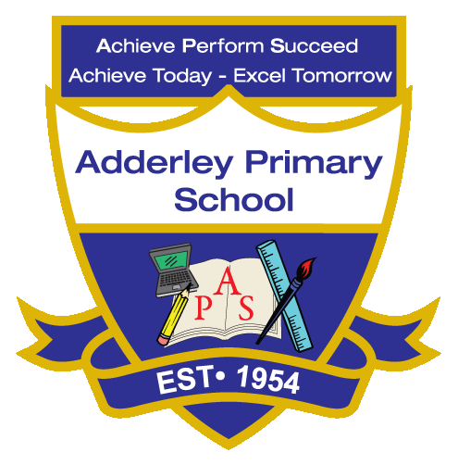
Music –Yearly Curriculum Plan (Parent Guide)

YEAR 3
 | AUTUMN |  | SPRING |  | SUMMER
 | HALF TERM 1 | HALF TERM 2 | HALF TERM 1 | HALF TERM 2 | HALF TERM 1 | HALF TERM 2
TOPIC/FOCUS | Scrumdiddlyumptious  & Cook Well, Eat Well  Ballads | Through the Ages  & Prehistoric Pots  Creating Compositions in Response to an Animation | Rocks, Relics  & Rumbles  Developing Singing Technique | Greenhouse &  Beautiful Botanicals  Pentatonic Melodies and Composition | Gods and Mortals  Jazz | One Planet, our World  Traditional Instruments and Improvisation
KEY KNOWLEDGE & SKILLS | Develop singing and performance skills, including phrasing, dynamics and expression. Understand that ballads tell a story through music, often with repeated verses and choruses, and convey emotions or events. | Develop composition skills by creating music to match visual media, experimenting with pitch, rhythm and dynamics. Understand how musical elements can represent characters, actions or environments and convey a narrative. | Develop vocal control, pitch accuracy, breathing and tone quality. Understand how to use posture, breath and articulation to improve singing and perform with expression. | Develop melody writing and composition skills using the pentatonic scale. Understand that a pentatonic scale contains five notes, and can be used to create simple, harmonious melodies. | Develop improvisation, rhythm, and ensemble playing skills. Understand that jazz uses swing rhythms, improvisation, call-and-response patterns and distinctive stylistic elements. | Develop instrumental skills, exploring timbre, rhythm and dynamics while improvising. Understand how different instruments produce sound and how improvisation allows performers to create spontaneous musical ideas within a structure.
ORACY OUTCOME | Performance Presentation | Storytelling Through Music | Demonstration | Peer Feedback Discussion |  | Demonstration & Peer Feedback
  Group Reflection

