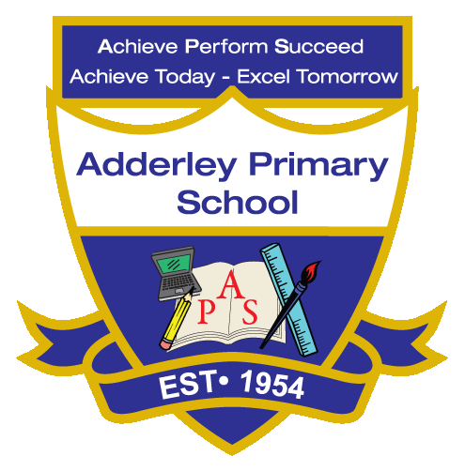
Design Technology –Yearly Curriculum Plan (Parent Guide)

YEAR 3
 | AUTUMN |  | SPRING |  | SUMMER
 | HALF TERM 1 | HALF TERM 2 | HALF TERM 1 | HALF TERM 2 | HALF TERM 1 | HALF TERM 2
TOPIC/FOCUS | Cross Stitch and Applique | Electric Poster | Pneumatc Toys | Wearable Technology | Eating Seasonally | Constructing a Castle
KEY KNOWLEDGE & SKILLS | Use cross stitch and appliqué techniques to decorate textile products, following a design plan and evaluating the finished piece. Understand that joining techniques attach fabric pieces, that templates help cut repeated shapes, and that drawing a design helps plan the final product. | Design and create posters that include simple electrical circuits, testing and adapting them to ensure components like bulbs or buzzers work. Understand that circuits need a complete path to allow electricity to flow, that switches control the flow, and that components must be connected correctly to function | Design and make pneumatic toys using syringes, tubing and balloons, testing and adapting mechanisms to improve movement. Understand that pneumatic systems use air pressure to move parts, that mechanisms like levers and sliders control motion, and that a design plan helps guide construction. | Plan and create wearable technology using coding, circuits or sensors, testing and adapting designs to ensure functionality. Understand that digital systems can control movement or light, that components must be connected correctly, and that prototypes help refine ideas. | Plan, prepare and evaluate seasonal dishes, tasting ingredients and suggesting improvements for flavour or presentation. Understand that seasonal foods are grown or harvested at specific times of year, that ingredients can be combined in different ways, and that tools and techniques affect the final product. | Design and build stable castle structures using a variety of materials, testing and improving stability during construction. Understand that strong shapes like triangles and cylinders add stability, that structures are built for a purpose, and that adding weight or supports can prevent toppling.
ORACY OUTCOME | Evaluation discussion | Product pitch | Radio presentation | Design presentation | Instruction explanation | Design presentation

