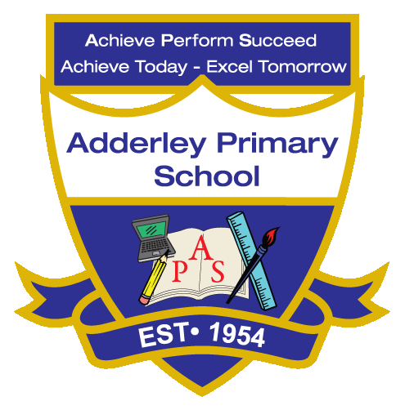
Writing –Yearly Curriculum Plan (Parent Guide)

YEAR 2
 | AUTUMN |  | SPRING |  | SUMMER
 | HALF TERM 1 | HALF TERM 2 | HALF TERM 1 | HALF TERM 2 | HALF TERM 1 | HALF TERM 2
TOPIC/FOCUS | Magnificent Monarchs  Non-Chronological Report  Character description | Muck, Mess and Mixtures &  Remarkable Recipes  Traditional Narrative  Instructions | Wriggle and Crawl  Narrative  Shape poem | Let’s Explore the World!  Postcard | Flower Head  Persuasive leaflet | Coastline  Diary  Letter
KEY KNOWLEDGE & SKILLS | A non-chronological report using clear headings. Focus on accurate use of capital letters and full stops. Description using co-ordinating and subordinate conjunctions, and adjectives to add detail. | Develop a traditional narrative using descriptive language, clear story structure and use of imagination.  A set of instructions focusing on using imperative verbs, time adverbials and conjunctions where appropriate. | A narrative with a logical sequence, using effective openers, co-ordinating and subordinate conjunctions.  A shape poem incorporating powerful verbs to convey action, clear sentence structure, and accurate punctuation. | A postcard to a different country, focusing on language features, time, tier 2 vocabulary, and a range of exclamation sentences. | A persuasive leaflet with organised headings, using persuasive language and structured sentences. | Diary entry using first-person and past tense. Focus on capital letters, full stops, finger spaces and Include exclamation marks.  Letter with appropriate greeting and closing use adjectives, verbs, time adverbials, and conjunctions to organise ideas clearly.
ORACY OUTCOME | Audio recording | Video presentation | Peer talk | Audio talk for children in Africa | Present persuasive leaflet to visitors of Botanical Gardens | Reading aloud

