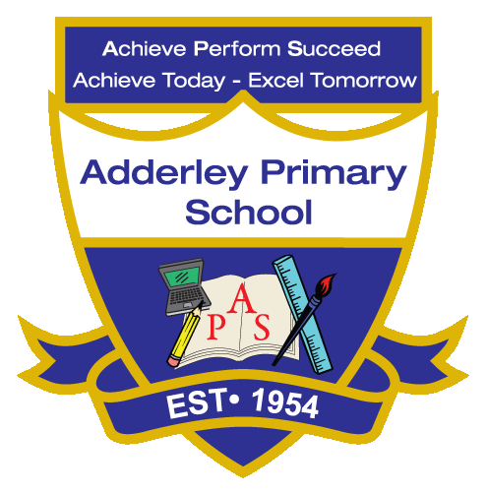
English Reading –Yearly Curriculum Plan (Parent Guide)

YEAR 2
 | AUTUMN |  | SPRING |  | SUMMER
 | HALF TERM 1 | HALF TERM 2 | HALF TERM 1 | HALF TERM 2 | HALF TERM 1 | HALF TERM 2
TOPIC/FOCUS | Magnificent Monarchs  The Very Last Castle by Travis Jonker | Muck, Mess and Mixtures &  Remarkable Recipes  Once upon a Sari by Zenia Wadhwani | Wriggle and Crawl  Anansi the Clever Spider | Let’s Explore the World!  Africa, Amazing Africa Country by Country by Atinuke | Flower Head  Africa, Amazing Africa Country by Country by Atinuke | Coastline  Little People, Big Dreams Greta Thunberg
KEY KNOWLEDGE & SKILLS | Pupils practise reading accurately and begin to read with greater fluency and confidence. Pupils focus on developing their language knowledge and recognising unfamiliar words in a range of texts.  Children learn to discuss the meaning of new vocabulary and think about how language is used in a story or text. They practise retrieval skills, which means finding information in the text to answer questions.  As pupils become more confident readers, they work towards reading texts more independently. They answer questions about what they have read, focusing on vocabulary and retrieval, and begin to develop simple inference skills, such as explaining how a character might feel or why something has happened.  Pupils read a range of different texts including stories, poetry and non-fiction. They talk about their favourite books, discuss characters and events, and explain what they think. Reading continues across the Curriculum, with pupils using books and texts in different subjects to support their learning and deepen their understanding.

