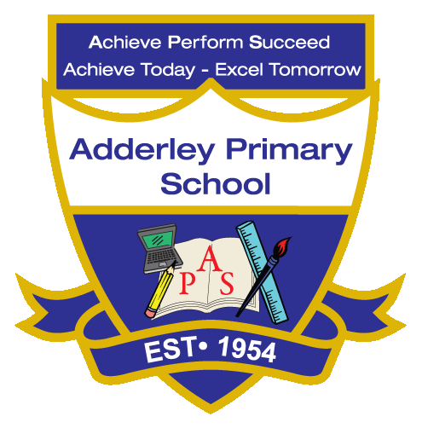
Music –Yearly Curriculum Plan (Parent Guide)

YEAR 2
 | AUTUMN |  | SPRING |  | SUMMER
 | HALF TERM 1 | HALF TERM 2 | HALF TERM 1 | HALF TERM 2 | HALF TERM 1 | HALF TERM 2
TOPIC/FOCUS | Muck, Mess and Mixtures & Remarkable Recipes  Call and Response | Magnificent Monarchs  Instruments | Wriggle and Crawl  Singing | Let’s Explore the World  Contrasting Dynamics | Flower Head  Structure | Coastline  Pitch
KEY KNOWLEDGE & SKILLS | Develop listening and performing skills by responding vocally or instrumentally in a call-and-response pattern. Understand that call-and-response is a musical structure where one phrase is “called” and another “responds,” helping to build rhythm, timing and ensemble awareness. | Explore and play a variety of instruments to support storytelling, identifying how sounds and textures enhance the narrative. Understand the role of different instrument types—percussion, wind, string—and how they can represent characters, events or moods. | Sing with expression, control, and awareness of pitch, rhythm and dynamics. Understand how vocal tone, phrasing and breathing convey meaning and enhance musical storytelling. | Experiment with loud and soft sounds in singing and instruments to create contrasting dynamics. Understand that dynamics change the mood, tension and effect of music. | Recognise and perform different musical sections, understanding patterns such as verse, chorus, repeated motifs or contrasting sections. Understand that musical structure organizes ideas and creates interest and clarity in a piece. | Identify and perform high and low sounds using voice or instruments. Understand that pitch determines how high or low a note sounds and can be used to create melody, mood and musical expression
ORACY OUTCOME | Performance Presentation | Demonstration | Storytelling Through Musi | Group Reflection | Presentation | Peer Feedback Discussion

