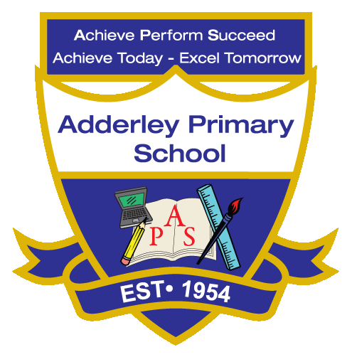
History –Yearly Curriculum Plan (Parent Guide)

YEAR 2
 | AUTUMN |  | SPRING |  | SUMMER
 | HALF TERM 1 | HALF TERM 2 | HALF TERM 1 | HALF TERM 2 | HALF TERM 1 | HALF TERM 2
TOPIC/FOCUS | Muck, Mess and Mixtures  &  Remarkable Recipes | Magnificent Monarchs | Wriggle and Crawl | Let’s Explore the World | Flower Head | Coastline
KEY KNOWLEDGE & SKILLS | Explore a local heritage site during Birmingham Heritage Week using VR images and pictures to discuss when the building was built. Talk about what life was like during the Tudor period, compare it with life today (including diet, clothing and furniture). Use storytelling, roleplay and hot seating to explore and discuss the site. | Understand the purpose of castles and why they were built, using Warwick Castle as an example.  Research a significant English monarch and learn about their role in history.  Identify and describe the roles of different people who lived and worked in the castle. | Learn about the history of the Amazon rainforest and the Indigenous people who have lived there for thousands of years.  Explore how Indigenous communities used the rainforest for food, shelter and medicine.  Understand how life in the rainforest has changed over time. | Explore how the local area has changed over time using photographs, maps, and aerial views of Birmingham.  Compare new and unchanged features and discuss why changes have occurred.  Link developments in housing and transport to population growth and community needs. | Explore how Birmingham Botanical Gardens has changed over time by comparing old and new photographs and creating a simple timeline. Learn about significant artists who painted plants and flowers, including Vincent van Gogh and Georgia O'Keeffe, and discuss their artwork and influence. | Learn how Blackpool has changed over time, looking at past and present images, maps, and landmarks.  Explore how tourism, transport, and buildings have developed in the town.  Learn about Captain James Cook and his significance in history.
ORACY OUTCOME | Hot seat a person from the Tudor period. | Roleplay – Life at Warwick Castle | Group discussion | Discussion- comparison | Class Presentation | Compare and contrast discussion

