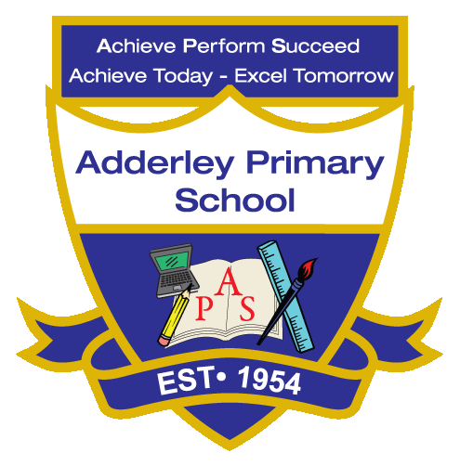
Geography –Yearly Curriculum Plan (Parent Guide)

YEAR 2
 | AUTUMN |  | SPRING |  | SUMMER
 | HALF TERM 1 | HALF TERM 2 | HALF TERM 1 | HALF TERM 2 | HALF TERM 1 | HALF TERM 2
TOPIC/FOCUS | Muck, Mess and Mixtures  &  Remarkable Recipes | Magnificent Monarchs | Wriggle and Crawl | Let’s Explore the World | Flower Head | Coastline
KEY KNOWLEDGE & SKILLS | Identify where food comes from and how it reaches us. Investigate which foods are grown locally and which are imported from Europe. Explore the seasons in which different foods grow and understand how seasonal changes affect their availability. | Use simple maps, aerial images and compass directions to describe the location of Warwick Castle and features around it, such as the River Avon and nearby towns.  Identify and describe human and physical features around the castle, such as rivers, parks and roads. | Learn about the Amazon rainforest and the insects that live there.  Discuss how rainforest insects are suited to a hot, wet environment.  Use simple maps to identify rivers, forests and animal habitats and compare them with local environments. | Locate the equator and the North and South Poles, describe hot and cold weather, and explain how climate affects people, animals, and plants.  Identify key features of the four countries and major cities of the UK and compare the local area to other regions. | Learn about the Botanical Gardens and the variety of plants they contain.  Visit and observe a variety of plants and flowers at the Botanical Gardens and carry out simple fieldwork.  Record observations and discuss what they see, including plant types and features. | Learn about the Blackpool coastline and locate Blackpool on a map including its position in the UK.  Understand map symbols and keys to identify and interpret different features. Explore and describe the physical and human features along the coast and how they shape the area.
ORACY OUTCOME | Show and Tell - foods | Map commentary | Group discussion | Map/Atlas activity- Question and answer session. | Share and discuss observations | Discussion- making comparisons.

