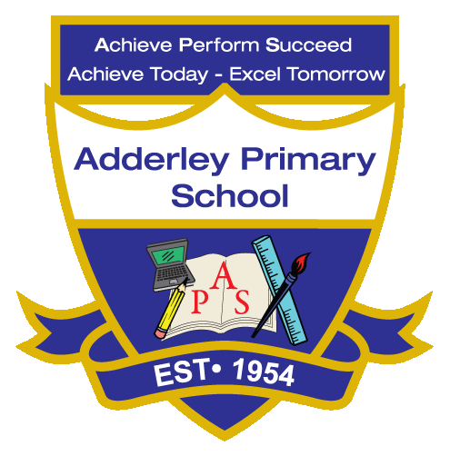
Writing –Yearly Curriculum Plan (Parent Guide)

YEAR 1
 | AUTUMN |  | SPRING |  | SUMMER
 | HALF TERM 1 | HALF TERM 2 | HALF TERM 1 | HALF TERM 2 | HALF TERM 1 | HALF TERM 2
TOPIC/FOCUS | Childhood and School Days  Fact file  Setting description | Paws, Claws  and  Whiskers  Adventure Narrative  Recount | Chops, Slice  and  Mash  Fairytale Narrative  Recipe Card | Our Wonderful World  Fact File | Bright Lights, Big City  Persuasive leaflet  Narrative | The Enchanted Woodland  Traditional Narrative Recount
KEY KNOWLEDGE & SKILLS | A fact file including research and organising writing using key facts. A setting description using adjectives, capital letters and full stops. | Writing an adventure narrative focusing on clear story structure, descriptive language and imagination. Using a range of verbs and conjunctions.  A recount retelling events in the correct order, focusing on developing accurate use of past and present tense. | Explore language features of a fairy-tale narrative, using capital letters, full stops and finger spaces.  A recipe card with clear instructions, focusing on sequencing, adjectives, verbs and correct punctuation. | Research countries such as Australia or Pakistan. Identify key facts and writing simple sentences using adjectives, nouns, subject verb object. Making cross-curricular links to Geography. | Identify features of persuasive writing, using tier 2 vocabulary.  Writing a narrative that follows a clear beginning, middle, and end, including capital letters, full stops and beginning to use exclamation mark. | Create descriptive words for a traditional narrative.  A recount learning to retell events in the correct order.  Focusing on using time words such as first, next and finally.
ORACY OUTCOME | Radio Presentation | Retell a story aloud with expression and intonation | Perform a short oral version of a fairytale | Reflective talk | Audio recording | Drama and role play

