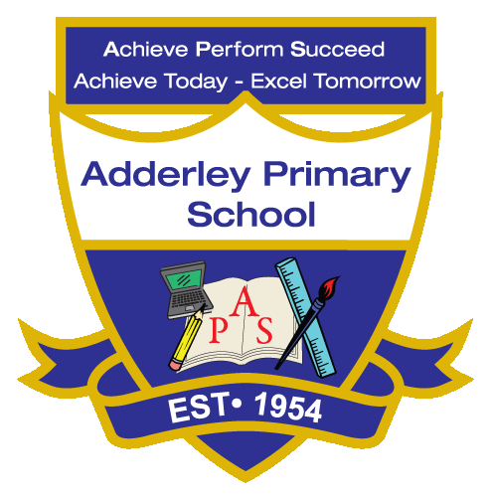
English Reading –Yearly Curriculum Plan (Parent Guide)

YEAR 1
 | AUTUMN |  | SPRING |  | SUMMER
 | HALF TERM 1 | HALF TERM 2 | HALF TERM 1 | HALF TERM 2 | HALF TERM 1 | HALF TERM 2
TOPIC/FOCUS | Childhood and School Days  ASFAP display | Paws, Claws  and  Whiskers  The Gruffalo by Julia Donaldson | Chops, Slice  and  Mash  Nadiya’s Bake me a Story Nadiya Hussain – The Never-Ending Porridge | Our Wonderful World  Nadiya’s Bake me a Story Nadiya Hussain – The Never-Ending Porridge | Bright Lights, Big City  Paddington at the Palace Michael Bond | The Enchanted Woodland  Anansi and Wisdom Storybooks Pakistan
KEY KNOWLEDGE & SKILLS | Pupils continue to develop their phonics knowledge and skills during Guided Reading sessions. They practise sounding out and blending unfamiliar words so they can read new words quickly and accurately. Pupils learn new grapheme–phoneme correspondences and use these to decode words when they are reading. This helps to strengthen their reading accuracy and confidence.  As pupils become more confident readers, they begin to read aloud with increasing fluency, expression and prosody. They learn to pay attention to punctuation such as full stops, capital letters and question marks. Children often re-read familiar texts to help them read more accurately using their phonics knowledge.  Pupils also begin to focus on developing their comprehension skills. During reading sessions, they talk about the story and explore the characters, key words and feelings in the text. Over time, they show that they understand the story and its meaning.  Reading takes place across the Curriculum, not only during English lessons. Pupils read in a variety of subjects such as Science, Creative Curriculum and Geography. They also visit the school library to explore different books and develop a love of reading.

