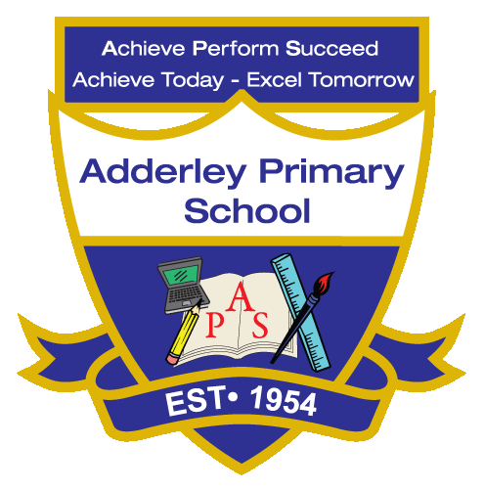
Music –Yearly Curriculum Plan (Parent Guide)

YEAR 1
 | AUTUMN |  | SPRING |  | SUMMER
 | HALF TERM 1 | HALF TERM 2 | HALF TERM 1 | HALF TERM 2 | HALF TERM 1 | HALF TERM 2
TOPIC/FOCUS | Childhood  & School Days  Keeping the Pulse (Theme: My Favourite Things) | Paws, Claws  and Whiskers  Tempo (Theme: Snail and Mouse) | Chops, Slice  and Mash  Dynamics (Theme: Seaside) | Our Wonderful World  Sound Patterns (Theme: Fairytales) | Bright Lights, Big City  Pitch (Theme: Superheroes) | The Enchanted Woodland  Musical Symbols (Theme: Under the Sea)
KEY KNOWLEDGE & SKILLS | Explore and perform a variety of songs, rhythms and simple instrumental pieces, developing singing, pulse, rhythm and pitch. Listen to, appraise and respond to different styles of music, using musical vocabulary to describe what they hear, and begin to create their own simple compositions using voice, body percussion and classroom instruments. | Explore and perform simple rhythmic patterns and songs inspired by animals, focusing on changes in tempo to represent slow and fast movements. Understand that tempo is the speed of the music and that it can change to create different moods or represent characters, such as a slow snail or a fast mouse. | Explore and perform songs and rhythms that reflect the seaside, using changes in dynamics to show loud and quiet sounds. Understand that dynamics describe how loud or quiet music is and that altering them can create mood, contrast and expression in a piece. | Explore and perform simple sound patterns and rhythms inspired by fairytales, using voice, body percussion and instruments. Understand that repeating and contrasting sound patterns can create rhythm, structure and storytelling in music. | Explore and perform songs and melodies using high and low pitches to represent superheroes and their actions. Understand that pitch describes how high or low a sound is and that changing pitch can create character, mood and expression in music. | Use simple musical symbols to plan, create and perform sounds inspired by the sea, experimenting with instruments, voice and body percussion. Explore how symbols can represent pitch, rhythm and duration, and understand that they help musicians read, record and develop their own compositions.
ORACY OUTCOME | Performance Presentation | Peer Feedback Discussion | Demonstration | Storytelling Through Musi | Group Reflection | Peer Feedback Discussion

