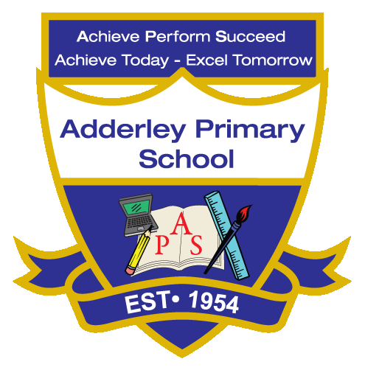
Art –Yearly Curriculum Plan (Parent Guide)

YEAR 6
 | AUTUMN |  | SPRING |  | SUMMER
 | HALF TERM 1 | HALF TERM 2 | HALF TERM 1 | HALF TERM 2 | HALF TERM 1 | HALF TERM 2
TOPIC/FOCUS | Blood Heart &  Circulatory System | Frozen Kingdom | A Child’s War &  Britain at War | Islamic Golden Age  Islamic Art | Islamic Golden Age  Islamic Art | Trailblazers, Barrier Breakers
KEY KNOWLEDGE & SKILLS | Create 3-D forms using malleable materials in the style of a significant artist, architect or designer. Understand how to research an artist and their period, using this knowledge to create innovative artwork with personal, historic or conceptual meaning, as seen in the life and work of Elaine de Kooning and the abstract art period. | Understand that environmental art explores social and political issues, that perspective can be used to represent 3-D objects on a 2-D surface, and that printmakers transfer paint, ink or other materials to create repeated or detailed designs. | Combine different materials, such as paper, fabric and print techniques, to create texture and visual interest in artwork. Understand that materials have distinct qualities—rough or smooth, heavy or light, fragile or robust—that can be used creatively, and that conceptual art focuses on the idea or message behind the work rather than just its appearance. | Explore the significance of Islamic art and design, creating work inspired by historical and contemporary artists such as Zahra Hussain. Combine materials, techniques to create effects in 2-D and 3-D work. Understand that Islamic art features calligraphy, arabesque and geometric patterns. | Explore the significance of Islamic art and design, creating work inspired by historical and contemporary artists such as Zahra Hussain. Combine materials, techniques to create effects in 2-D and 3-D work. Understand that Islamic art features calligraphy, arabesque and geometric patterns. | Understand the significance of artworks and artists from different times and cultures, and use their ideas, elements and techniques to inspire original work. Adapt and refine artwork based on constructive feedback and reflection, recognising that in conceptual art the idea or concept is more important than the final appearance.
OACY OUTCOME | Presentation | Design Justification | Peer Feedback | Reflective Discussion | Comparative Talk | Conceptual Explanation

