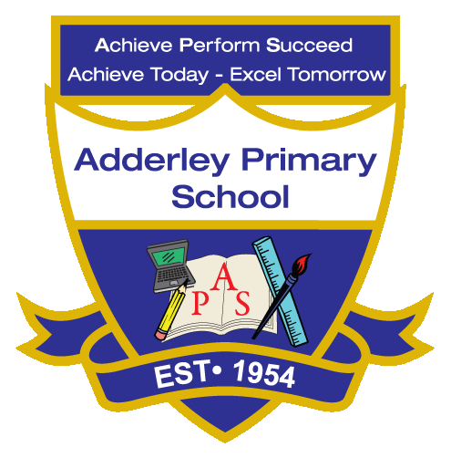
Art –Yearly Curriculum Plan (Parent Guide)

YEAR 5
 | AUTUMN |  | SPRING |  | SUMMER
 | HALF TERM 1 | HALF TERM 2 | HALF TERM 1 | HALF TERM 2 | HALF TERM 1 | HALF TERM 2
TOPIC/FOCUS | Stargazers & Earth and Space | Fallen Fields (WW1 & 2) | Sow, Grow and Farm & Allotment | Firedamp & Davy Lamps | Firedamp & Davy Lamps | Pharaohs
KEY KNOWLEDGE & SKILLS | Use artwork as inspiration to create mixed-media pieces by layering materials, adding printed text or images and combining drawing and colour techniques. Understand that artists such as Vincent van Gogh use colour, texture and composition to create meaning, and that selecting materials carefully helps achieve different artistic effects. | Review and revisit sketches to develop and refine ideas, using annotations, practice and experimentation to improve techniques. Understand how colour and tone can influence mood in artwork and use drawings as the basis for developing a final painting. | Mix and apply tints and shades using a range of materials, understanding that tints are created by adding white and shades by adding black to a colour. Explore still life artwork by artists such as Michelangelo Merisi da Caravaggio, Claude Monet and Vincent van Gogh, and learn how artists arrange objects to create visually appealing compositions inspired by themes such as farming and agriculture. | Describe and discuss how different artists and cultures use visual elements such as colour, texture and pattern in their work. Understand that artists plan and develop ideas through sketches and models, enhancing natural materials or creating intense visual effects, and that different periods and styles use visual elements to convey meaning and create distinctive works. | Describe and discuss how different artists and cultures use visual elements such as colour, texture and pattern in their work. Understand that artists plan and develop ideas through sketches and models, enhancing natural materials or creating intense visual effects, and that different periods and styles use visual elements to convey meaning and create distinctive works. | Produce creative work on a theme by developing ideas through preliminary sketches and models, exploring techniques in drawing, colour and form. Understand that sketches and trial sculptures help plan a final piece, and that studying artists from the Egyptian period provides inspiration for subject matter, style and techniques.
OACY OUTCOME | Presentation | Design Justification | Peer Critique | Comparative Analysis | Artistic Storytelling | Historical Context Discussion

