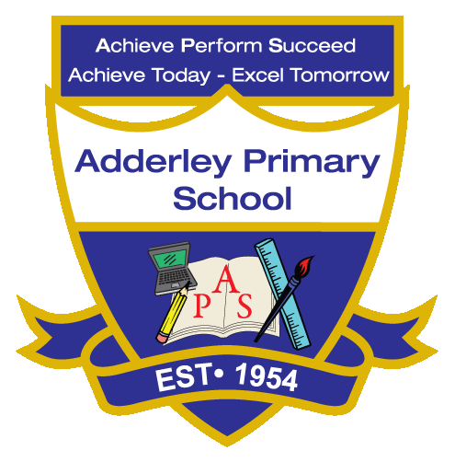
Art –Yearly Curriculum Plan (Parent Guide)

YEAR 4
 | AUTUMN |  | SPRING |  | SUMMER
 | HALF TERM 1 | HALF TERM 2 | HALF TERM 1 | HALF TERM 2 | HALF TERM 1 | HALF TERM 2
TOPIC/FOCUS | Misty Mountains and Winding Rivers | Functional and Fancy Fabrics | Potions & Islamic Physicians | I am Warrior! | I am Warrior! | Misty Mountain Sierra
KEY KNOWLEDGE & SKILLS | Sculpt and decorate mountains using Modroc, building over an armature and applying paint, textures and decorations to create realistic landscapes. Understand how to use wet-to-dry modelling materials, that art can show unusual perspectives or viewpoints, and that evaluating their work helps improve technique, sturdiness and visual effect. | Explore and create decorative textiles by developing drawing, printing and embroidery techniques. Design motifs, create repeated patterns using block printing and embellish fabric with a range of stitches, understanding that textiles can be decorated using different materials, techniques and artistic influences. | Create 3-D clay forms using techniques such as coiling, pinching, slab construction and sculpting, adding detail through carving, slip and score and mark making. Understand that artwork can express ideas about storytelling, religion and culture. | Use sketchbooks to develop ideas over time. Understand that artists combine visual elements such as line, tone, shape, pattern, colour and form to depict the human figure and create narratives, and that historical artworks can reveal information about the past through symbolism, materials and artistic choices. | Use sketchbooks to develop ideas over time. Understand that artists combine visual elements such as line, tone, shape, pattern, colour and form to depict the human figure and create narratives, and that historical artworks can reveal information about the past through symbolism, materials and artistic choices. | Develop skills in drawing, painting, sculpture and textiles, including stitches such as running stitch, cross stitch and blanket stitch, while understanding how warm and cool colours and different perspectives can influence mood and composition in artwork.
OACY OUTCOME | Technical Discussion | Comparative Talk | Peer Feedback | Design Explanation | Presentation | Storytelling

