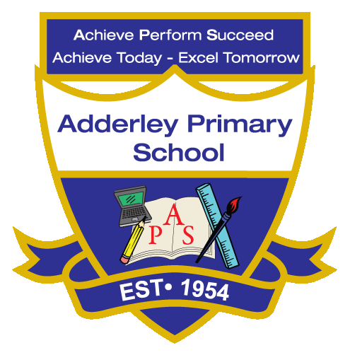
Art –Yearly Curriculum Plan (Parent Guide)

YEAR 3
 | AUTUMN |  | SPRING |  | SUMMER
 | HALF TERM 1 | HALF TERM 2 | HALF TERM 1 | HALF TERM 2 | HALF TERM 1 | HALF TERM 2
TOPIC/FOCUS | Scrumdiddlyumptious  & Cook Well, Eat Well | Through the Ages  & Prehistoric Pots | Rocks, Relics  & Rumbles | Greenhouse &  Beautiful Botanicals | Gods and Mortals | One Planet, our World
KEY KNOWLEDGE & SKILLS | Experiment with colour, line, shape, pattern and tone in drawing, painting and sculpture using a range of materials, including pencil, charcoal, paint and clay. Understand that malleable materials like clay and papier-mâché can be shaped easily, while rigid materials like cardboard or wood require cutting and joining. | Use preliminary sketches in a sketchbook to explore ideas, experiment with techniques and plan a final piece of artwork. Understand that sketches are quick line drawings often done in pencil, that Bronze Age artists created decorated pottery such as bell beakers, and that researching historical artwork can inspire creative designs. | Work in the style of a significant artist, architect, culture or designer, using their techniques, materials and subject matter for inspiration. Draw, human forms in a variety of poses using pencils and create 3-D forms with malleable materials like clay or papier-mâché, or rigid materials such as cardboard or wood, understanding that some materials require cutting and joining to achieve the desired shape. | Use preliminary sketches in a sketchbook to explore ideas, experiment with techniques and record observations through annotations. Work in the style of a significant artist, architect, culture or designer, understanding that their work has distinctive features, including subject matter, movement and the techniques and materials they use. | Plan and create 3-D sculptures of gods and goddesses using wire armatures with papier-mâché or Modroc, painting to achieve effects such as stone or marble. Understand that malleable materials are easy to shape while rigid materials require cutting and joining, and that artists’ techniques, materials and styles can be compared and adapted to inspire new work. | Create 3-D dioramas representing different landscapes, using sketches to design the background, middle and foreground. Understand that a diorama is a model representing a scene, that materials can be chosen to show different surfaces and textures, and that combining drawing, painting and sculpting techniques helps improve realism and detail.
ORACY OUTCOME | Presentation | Design Explanation | Peer Feedback | Storytelling | Technical Discussion | Comparative Talk

