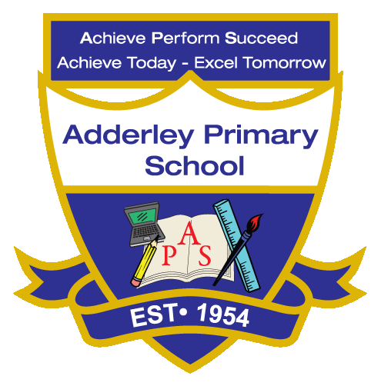
Art –Yearly Curriculum Plan (Parent Guide)

YEAR 2
 | AUTUMN |  | SPRING |  | SUMMER
 | HALF TERM 1 | HALF TERM 2 | HALF TERM 1 | HALF TERM 2 | HALF TERM 1 | HALF TERM 2
TOPIC/FOCUS | Muck, Mess and Mixtures & Remarkable Recipes | Magnificent Monarchs | Wriggle and Crawl | Let’s Explore the World | Flower Head | Coastline
KEY KNOWLEDGE & SKILLS | Explore and experiment with a variety of materials, tools and techniques to create different textures, patterns and effects. Understand that materials can be mixed, layered and manipulated in different ways to produce new colours, textures and forms in artwork. | Draw, paint and create artwork to represent monarchs, experimenting with colour, pattern and detail. Understand that careful observation and use of line, shape and colour can represent clothing, crowns and regalia accurately. | Explore drawing, painting and collage to represent animals and insects, focusing on movement and patterns. Understand that texture, shape and repeated marks can show the way creatures move or the surfaces they live on. | Create drawings, paintings or collages inspired by different places and landscapes, experimenting with media to show features like rivers, mountains and trees. Understand that observation, imagination and memory can all be used to create artwork that represents real or imagined places. | Design and create flower-inspired artwork using drawing, painting or collage, exploring shape, colour and texture. Understand that natural forms can be simplified into shapes and patterns to represent petals, leaves and stems. | Draw, paint or model coastal landscapes, experimenting with colour, texture and layering to show land, sea and sky. Understand that using different materials and techniques can represent natural features such as sand, rocks and waves.
ORACY OUTCOME | Discussion | Presentation | Discussion | Storytelling Through Art | Design Explanation | Peer Feedback

