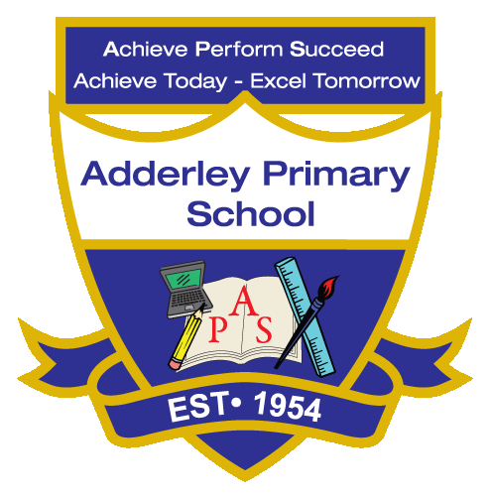
Art –Yearly Curriculum Plan (Parent Guide)

YEAR 1
 | AUTUMN |  | SPRING |  | SUMMER
 | HALF TERM 1 | HALF TERM 2 | HALF TERM 1 | HALF TERM 2 | HALF TERM 1 | HALF TERM 2
TOPIC/FOCUS | Childhood & School Days | Paws, Claws and Whiskers | Chop, Slice and Mash | Our Wonderful World | Bright Lights, Big City | The Enchanted Woodland
KEY KNOWLEDGE & SKILLS | Draw, paint or sculpt the human face from observation or imagination, exploring different tools such as pencils, crayons, pastels and chalk. Understand that a face has features like eyes, nose, mouth and cheeks. Explore different fabrics to design clothing, noticing their properties such as thickness or warmth. | Use soft and hard pencils to create different types of line and shape, such as zigzag, wavy, curved, thick and thin. Discuss own or others’ work using simple artistic vocabulary, noticing subject, colour, shape, techniques and feelings. Understand that collage involves layering and sticking materials to make artwork. | Draw objects and faces from observation or imagination using different pencils and line types. Mix colours to create shades and tints, explore simple collages with paper and fabric, and talk about their own and others’ artwork using simple artistic vocabulary. | Experiment with different media, brush sizes and tools, and create simple prints using materials such as corks, sponges or pen barrels. Draw textures and patterns using line, explore ways to add colour like paint, crayons or collage, and understand that printing involves making imprints with materials. | Draw using soft and hard pencils, experimenting with different types of line such as zigzag, wavy, curved, thick and thin. Explore charcoal as a medium, blending and applying it in different ways to create effects, and understand that different media can be chosen to achieve different visual results. | Create transient art and patterns using natural and man-made materials, experimenting with texture, shape and form. Use primary colours in painting and explore different art techniques, understanding that transient art is temporary and can be moved or rearranged.
ORACY OUTCOME | Presentation | Art Critique | Peer Feedback | Demonstration | Storytelling | Presentation

